Google Play store App Performance & User Engagement Analytics
Project Overview:
Google Play Store App Performance & User Engagement Analytics is a data analytics project that analyses Google Play Store app data to understand app ratings, reviews, installs, pricing, categories, and user engagement. The project involves data cleaning, transformation, feature engineering, and EDA using Python, followed by visualization and dashboard preparation in Power BI to generate meaningful insights into app performance.
Project Objective:
The objective of this project is to analyse Google Play Store application data to understand app performance, user engagement, ratings, installs, pricing, categories, and other important factors.
The project focuses on:
- Cleaning and pre-processing the raw dataset
- Analysing app ratings and user reviews
- Understanding app installation trends
- Comparing free and paid applications
- Identifying popular app categories
- Studying user engagement through reviews and installs
- Creating meaningful data-driven insights
- Preparing the cleaned dataset for Power BI visualization
Dataset Overview:
The Google Play Store Apps Dataset contains information about Android applications, including their categories, ratings, reviews, installs, pricing, size, and other app details. With approximately 10,841 records and 13 columns, it is used to analyse app performance, popularity, user engagement, and free-versus-paid app trends.
Dataset Information:
- Dataset: Google Play Store Apps Dataset
- Source: GitHub – MainakRepositor/Datasets
Dataset File: googleplaystore.csv
- Approximate Size: 10,841 rows × 13 columns
- Format: CSV
- Domain: Mobile Applications / App Store Analytics

Dataset Columns:
Column | Description
App | Name of the application
Category | App category
Rating | Average user rating
Reviews | Number of user reviews
Size | Application size
Installs | Number of installations
Type | Free or Paid
Price | Application price
Content Rating | Age/content rating
Genres | App genre
Last Updated | Date the app was last updated
Current Ver | Current version
Android Ver | Required Android version

Stage 1 – Problem Definition and Dataset Selection

Business Problem and Expected Outcome
The objective is to analyse Google Play Store applications to understand app popularity, user engagement, ratings, installation trends, and pricing patterns.
The analysis will help identify popular app categories, evaluate app ratings and user reviews, understand installation patterns, compare free and paid applications, and identify factors associated with app popularity and user engagement.

Dataset Selection
The Google Play Store Apps dataset is selected for this project. It contains information about applications available on the Google Play Store, including app names, categories, ratings, number of reviews, app size, number of installs, app type, price, content rating, genres, last updated date, current version, and required Android version.
The dataset provides useful information for analysing application performance, user engagement, popularity, and pricing patterns across different app categories.

Stage 2 – Data Cleaning, Transformation and Feature Engineering
In Stage 2, the Google Play Store dataset was cleaned and prepared for further analysis using Python and Pandas. The process included handling missing values and duplicates, removing invalid data, cleaning text fields, converting columns into appropriate numeric and datetime formats, and standardizing values such as app size, installs, price, ratings, and application type.

Feature engineering was then performed to create meaningful analytical features such as Updated Year, Updated Month, Review-to-Install Ratio, and Popularity Category. After the pre-processing and feature engineering process, the dataset was finalized with 10,357 rows and 17 columns, making it ready for EDA and visualization in Stage 3.

Stage 3 – Exploratory Data Analysis and Visualization
In Stage 3, Exploratory Data Analysis (EDA) was performed on the cleaned Google Play Store dataset to identify important patterns, trends, relationships, and distributions in the data. Univariate, bivariate, and multivariate analyses were carried out using statistical summaries and suitable visualizations.
Different charts such as bar charts, count plots, pie charts, histograms, box plots, line charts, scatter plots, and heatmaps were used to analyse app categories, ratings, reviews, installs, app size, pricing, app type, and update trends. The analysis helped understand user engagement, app popularity, rating patterns, and relationships between different variables.
The findings from the EDA were interpreted to generate meaningful insights about app performance and user engagement. The visualizations and insights obtained in this stage were also used as a foundation for the final Power BI dashboard and project conclusions.

Final – Insights, Power BI Dashboard and Conclusion

Key Insights
The analysis of the Google Play Store dataset provided several useful insights into app performance and user engagement. The major findings include:
- Free applications represent a much larger portion of the dataset compared with paid applications.
- Apps with a higher number of installations generally indicate greater popularity and user reach.
- User reviews provide an important measure of engagement and can be compared with installations using the Review-to-Install Ratio.
- App categories show differences in the number of applications, ratings, reviews, and installations.
- Most applications fall under the Most Popular category based on the installation-based popularity classification.
- The analysis of ratings, reviews, and installations helps identify patterns in app popularity and user engagement.

Power BI Dashboard
The cleaned and feature-engineered dataset was imported into Power BI to create an interactive dashboard. The dashboard presents important KPIs and visualizations related to app ratings, reviews, installations, app categories, pricing, app type, popularity, and update trends.
Interactive filters and charts allow users to explore the dataset from different perspectives and easily compare app performance across categories and application types. The Power BI dashboard converts the analytical results obtained from Python into an interactive and user-friendly format.

Conclusion
This project successfully analysed Google Play Store application data using Python, Pandas, Matplotlib, Seaborn, and Power BI. The project covered the complete data analytics process, including dataset selection, data cleaning, transformation, feature engineering, exploratory data analysis, visualization, and insight generation.
The analysis helped identify patterns related to app popularity, user engagement, ratings, installations, categories, pricing, and free-versus-paid applications. The final Power BI dashboard provides an interactive way to explore these findings and supports better understanding of Google Play Store app performance and user engagement.
Screenshot of Power BI Dashboard:

Page 1: Overview
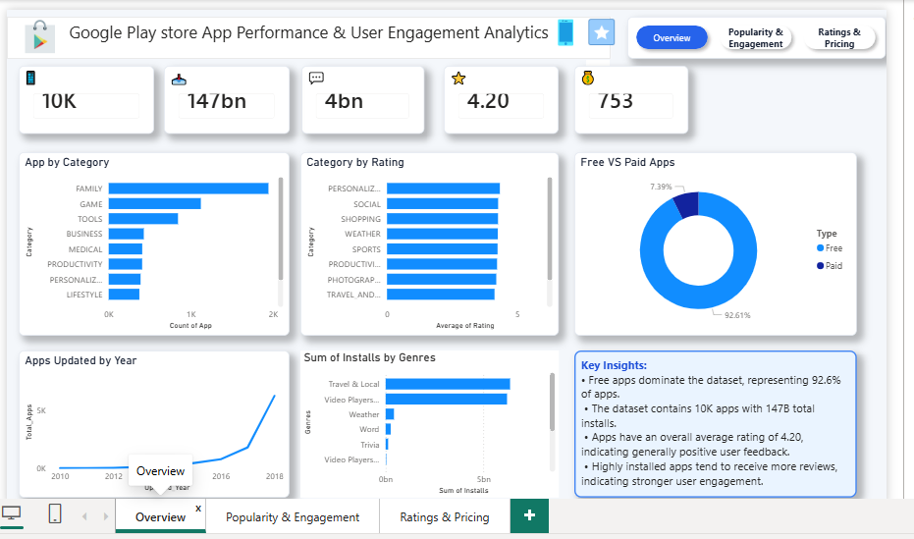

Page 2: Popularity& User Engagement
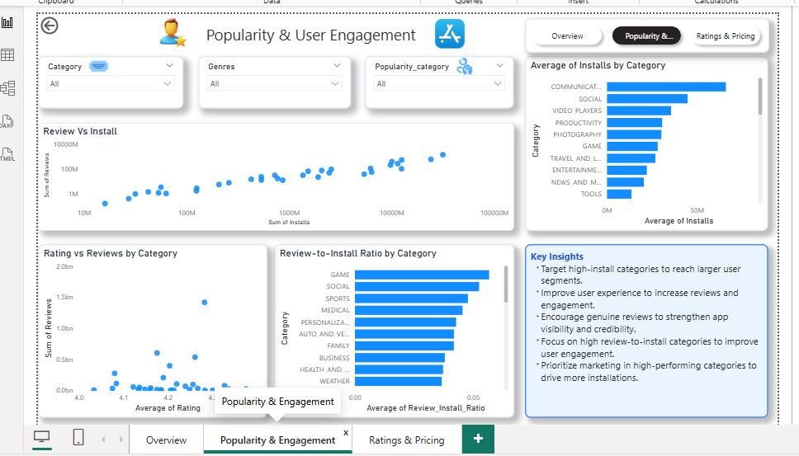

Page 3: Rating & Pricing
